# Gantt Chart

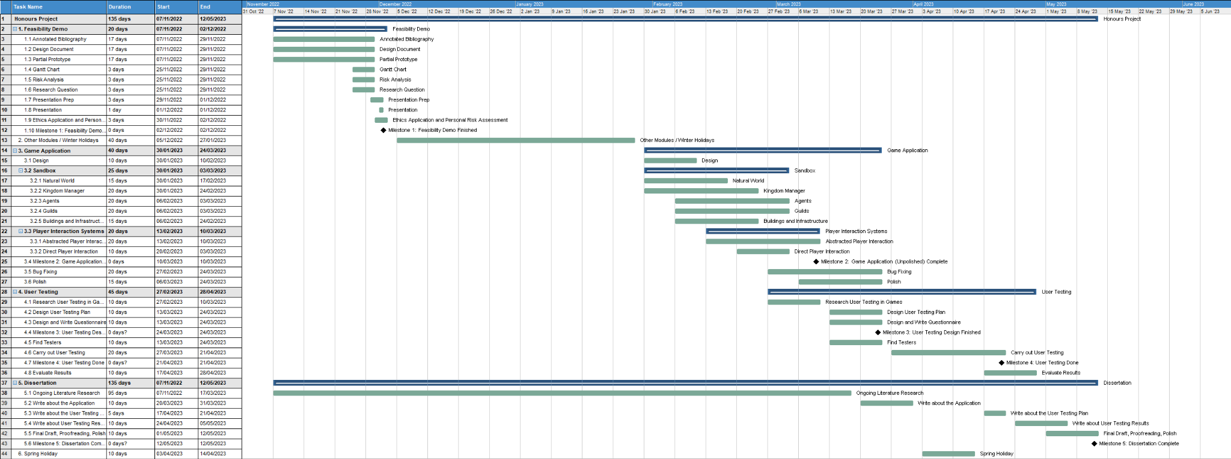

# 

# Risk Analysis

## Programming data loss

* Avoidance – Use a github repo and regularly commit and push

## Non-Programming files data loss (for example: questionnaire results)

* Avoidance – Make regular backups, make use of cloud services such as google docs

## Computer Failure

* Contingency – If work is all backed up, default to using the computers on campus / in the library

## Over-Scoping, failure to finish application in enough time for user testing

* Avoidance – Regularly asses the pace of the project and reduce scope early. Prioritise essential elements of the application.

# 

# Research Question

Can pairing a complex game world with a more abstracted player interaction system make for an engaging and accessable game while preserving the depth that a complex game world usually provides?

## Aim

To design and develop a detailed game world simulation with two systems of player interaction, one consisting of simple and abstracted levers of player interaction, and one giving the player more direct control. This project will attempt to evaluate how effective the first system is at keeping player interaction simple, engaging, and accessible while still gaining depth from the detail and complexity of the game world in comparison to the second system.

## Objectives

* Research and compare methods of constructing complex game worlds.
* Design two separate systems of player interaction for the sandbox simulation, one giving direct control of elements in the simulation, and one providing more abstracted controls
* Investigate how the systems of player interaction can be best implemented.
* Incorporating the above select compatible approaches for the construction of the game world and the two player interaction systems
* Construct a prototype sandbox simulation showcasing a complex game world simulation with the two distinct systems of player interaction
* Review the success of the selected approaches on relevant performance metrics and with respect to general development principles
* Use user testing to analyze the effectiveness of each system in terms of depth, simplicity, accessibility, engagement, and comprehensibility
* Assess the effectiveness of the more abstracted player control system at being more accessible and easy to understand without obscuring from the player the depth and detail of the game world simulation or compromising too significantly the player’s sense of agency